S.No | Name of the Inventor | Signature of the Inventor
 | Mr P.Praveen | 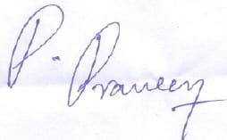
 | G .Abhishek | 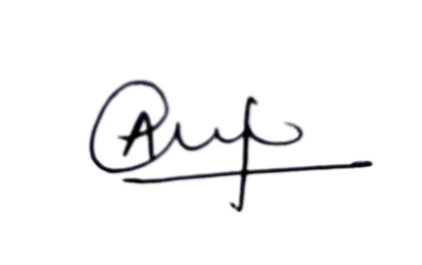
 | Y .Saketh | 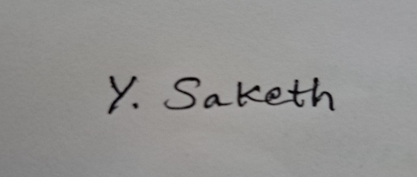
 | Mrs.Vasundhara | 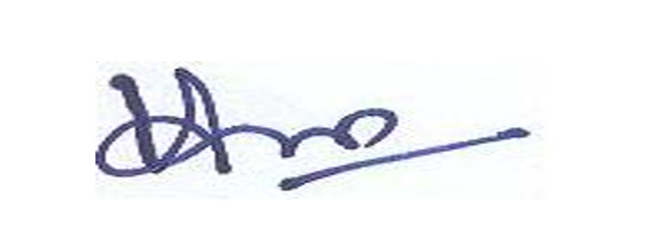
 | Mr.B.Sangameshwar | 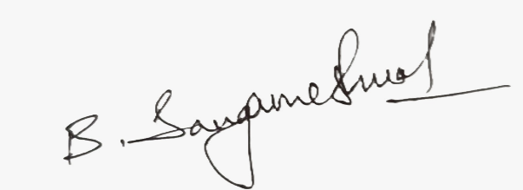
 | Mr Sadham Hussain | 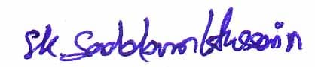
 | G .Sai Srujith | 